Wajahat khan

**How to compile the program from the Command Center?**

First step is to Download JDK and Eclipse.

- Eclipse is an integrated development environment (IDE) used in computer programming.

- To compile the program, we have to make sure that Command Center recognize the JDK. JDK is Java Development Kit that is required to compile the Java programs. So, before we compile the program, we will need to make sure that Javac is in working order from command center. If not, then we have to Path JDK in the system.

- To Path JDK in the system- First step to locate the JDK bin folder location. Once, we have located your JDK bin, then copy the location – go to control panel – System and security – System – Advanced System Settings - Advanced tab - Environment Variables, then create new Path under user variables and copy the location under Variable value and name Variable as Path.

Second step is to compile the Java program from Command Center.

* To compile the program, click the start menu, and then search Cmd, which will prompt you to the command center.
* Next step is to locate the program folder from the Command Canter. In Command Prompt window, type dir – this will provide you the all the folder names in C drive. Once, you have located the Program folder in the directory, then open that folder by typing cd & the folder name just like the picture below:

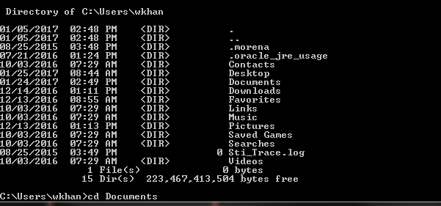

* Once the Java file is located from the command center, then we can compile. To compile the program, type javac HelloWorld.java – Press enter. This will create a class file, which means now you can run the program by typing the name of the program from the command center.
* Congratulation, now you have learn how to compile the java program.